xConnect System Support - xTP

**Revision History**

|  |  |  |  |
| --- | --- | --- | --- |
| Rev | Date | Author | Description |
| 1.0 | 7/16/2012 | Steve Groth | Release Version |

**Document Approvers & Sign-Off**

|  |  |  |  |
| --- | --- | --- | --- |
| Date | Approver | Role | Document Accept/Reject |
| [Date] | [Insert Approver’s Name] | [Insert role] | [Accept/Reject] |

**Table of Contents**

[1 Introduction 4](#_Toc335198799)

[1.1 Definitions 4](#_Toc335198800)

[2 System Function Description 6](#_Toc335198801)

[3 High-Level Drawings and Diagrams 6](#_Toc335198802)

[3.1 Top Level and Main Components Diagrams 7](#_Toc335198803)

[3.2 The Electronic Components 9](#_Toc335198804)

[3.3 The RFID Chain 10](#_Toc335198805)

[4 Description of Interfaces 12](#_Toc335198806)

[5 System Interconnect Diagram 13](#_Toc335198807)

[6 Communication System Diagrams 14](#_Toc335198808)

[7 Subsystem Assembly Drawings 15](#_Toc335198809)

[8 Component Data Sheet 16](#_Toc335198810)

[9 Supply Chain Information 17](#_Toc335198811)

[10 Troubleshooting Guide 18](#_Toc335198812)

[10.1 Removing and replacing the xTP 18](#_Toc335198813)

[10.2 xTP Bring-up: xTP/xBRC Association 23](#_Toc335198814)

[10.3 Testing the xTP 27](#_Toc335198815)

[10.4 Troubleshooting problems with the xTP 28](#_Toc335198816)

[11 Obsolete Equipment 29](#_Toc335198817)

# Introduction

This document provides a description of the high-level design for the xTP. This includes:

* A list of definitions for the terms used in this document
* A high-level functional description of the purpose of the xTP
* A series of drawings and diagrams showing the main components of the xTP
* A series of drawing showing the assembly of the xTP
* A component data sheet table listing the physical, environmental, electrical, and regulatory features of the xTP
* Supply chain information
* Detailed information about how to diagnose and troubleshooting any problems you may encounter when installing and using the xTP
* Information about the handling of obsolete equipment

## Definitions

For this document, the following acronyms are used:

|  |  |
| --- | --- |
| **Term** | **Definition** |
| DAP: | Disney Access Portal, an xTP configured with a biometric reader for use at Park Entry locations. |
| ESB | Enterprise Service Bus. |
| GxP: | Code that handles entitlements for FastPass+. |
| HTTP: | Hypertext Transfer Protocol. |
| IDMS: | Code and database storing Guest and MagicBand information. |
| JSON | JavaScript Object Notation. |
| JMS: | Java Message Service. |
| MagicBand: | RFID device worn by Guests. |
| REST | Representational State Transfer. |
| RFID: | Radio-frequency identification. |
| xBR: | Long range RFID reader with uni- or omni-directional antennae. |
| xBRC: | Code package that manages xBRs, xTPs, and DAP devices. |
| xBRMS: | Code and database which stores operational data. |
| xConnect: | Code, scripts, APIs, and database schemas which comprise the unifying messaging, management, and reporting software that ties the hardware together into a coherent solution. |
| xi | Exchange Infrastructure. |
| XML | Extensible Markup Language. |
| xTP: | Experience TouchPoint, a Disney-themed short range RFID reader or “touch” device. Note that in other documents “xTP” is used to describe the entire unit; however, in this document it is a component piece of the overall assembly. |

# System Function Description

The xTP is a second generation E**x**perience **T**ouch **P**oint. The primary function of the xTP is to read RFID tags (embedded either in cards or in a wrist worn MagicBand) and to relay that information from these tags to the xBRC system using an Ethernet connection. When the xTP is used for Park Entry it is referred to as a Disney Access Portal (DAP) and when it is used at different locations in the park, it is referred to as a Touch Point (xTP). The xTP also includes a high brightness RGB LED display, sound for user feedback, and a USB port to connect to a biometric (fingerprint) reader.

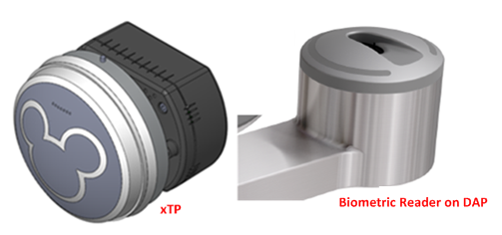

Figure 2.: xTP and Disney Access Portal (DAP)

# High-Level Drawings and Diagrams

The following diagrams and drawings provide different perspectives of the xTP and its role in the xConnect system. This includes:

* A top level block diagram that shows how the xTP fits into the xConnect System
* The main components of the xTP and its internal and external connections
* The electronic components of the xTP
* The RFID components of the xTP

## Top Level and Main Components Diagrams

See section 1.1 for a list of acronyms used in this document.

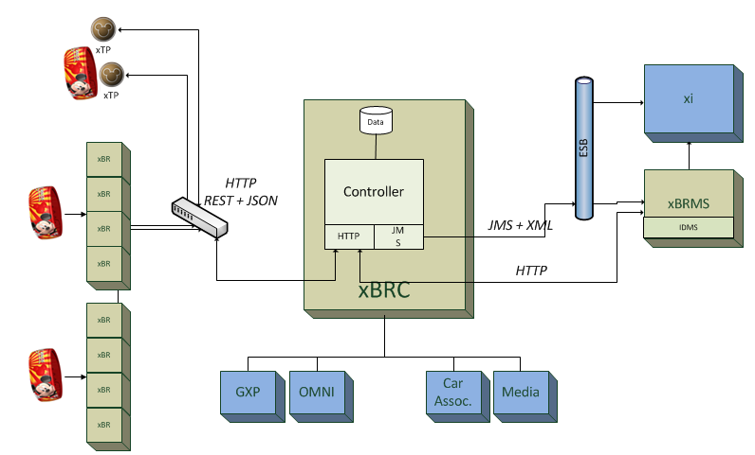

Figure 3.1: xTP High Level Overview

Figure 3.2 shows the main components of the xTP and its internal and external connections.

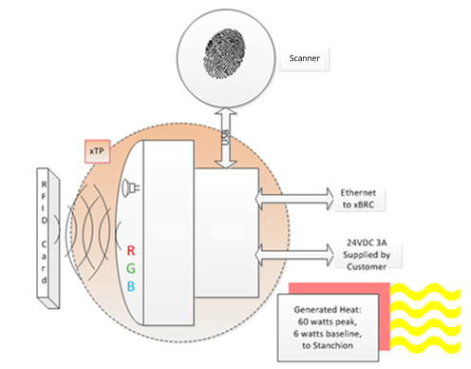

Figure 3.2: xTP Top Level Diagram

## The Electronic Components

This section shows the xTP and xTPE and main electronic components of the xTP.

Figure 3.3 shows the two main components of the xTP: the xTPX and xTPE, and the assembled xTP.

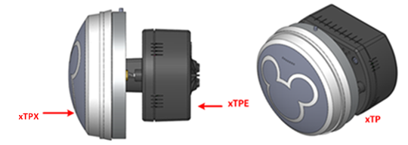

Figure 3.3: xTP and xTPE

Figure 3.4 shows the main electronic components of the xTP.

Shown in green, there are four printed circuit boards that make up the xTP electronics. The functions and interconnections of these printed circuit boards are shown below.

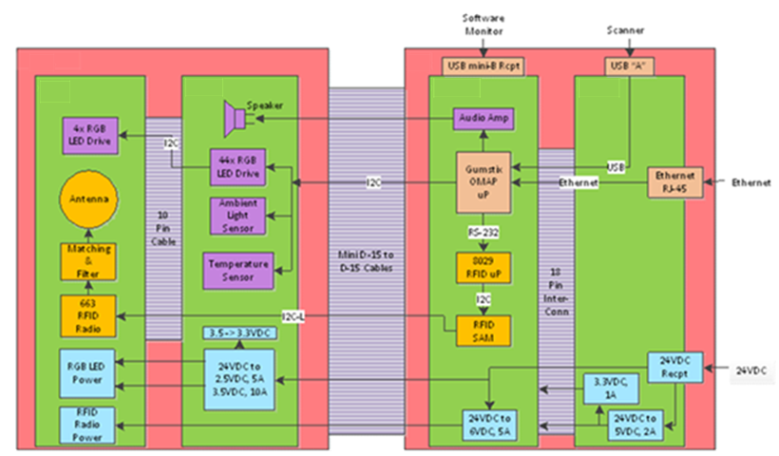

Figure 3.4: xTP Electronic Components

## The RFID Chain

Figure 3.5 shows the RFID components of the xTP. The RFID chain is based on the following parts:

* A TDA8029HL reader control IC (Integrated Circuit)
* A P5DF081HN\_T1AR1070 RFID Secure Access Module (SAM)
* A CLRC66301HN,551 reader radio transceiver (XCVR) IC

The XCVR IC is followed by an analog matching and filtering circuit that optimally connects the XCVR to the antenna coil.

The reader control IC is a preprogrammed microprocessor used to decode and implement high-level commands sent from a host computer via UART (Universal Asynchronous Receiver/Transmitter). The host in this case is the Gumstix card.

To unburden the system of time consuming tasks, the integrated SAM chip decodes commands from the reader chip like verification of a secure link between the reader and an external tag. Allowing the SAM chip to perform these tasks locally speeds up RFID transactions because communication between the host and the XCVR is minimized.

The SAM chip also communicates with the XCVR IC using a modified I2C communications methodology called I2C-L. This short range, point to point serial protocol runs at about 2.5Mbaud. No pullups are required on either the clock or on data lines.

The XCVR’s analog interface is made up of a differential output, a differential input, and a bias voltage.

Figure 3.5 shows the RFID signal flow.

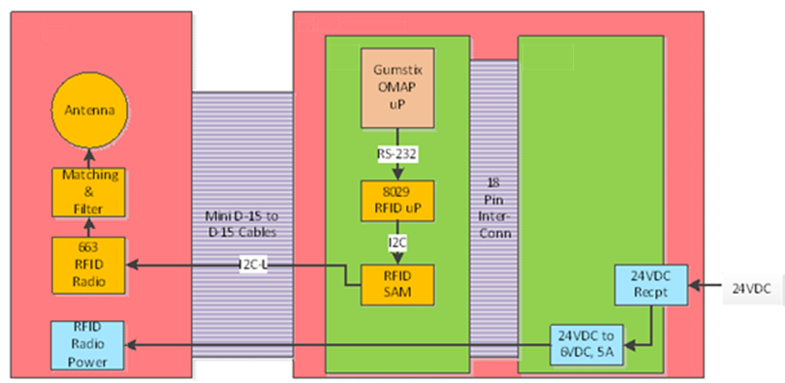

Figure 3.5: RFID Signal Flow Diagram

# Description of Interfaces

When used for Park Entry, the xTP has a biometric reader attached and is referred to as the DAP. The xTP can be configured for Park Entry, FastPass+ Queues or other areas like restaurant’s Great Food Fast (GFF) program. The xTP will detect an RFID card or MagicBand within close proximity in order to read ID information.

An xTP is associated with one xBRC. The xBRC assists in determining entitlement status for a guest by placing JMS messages on the ESB (Enterprise Service Bus) which are then consumed by other downstream applications (xBMS, GxP, xi, etc.). The following outlines how the xTP is used:

Park Entry:

* When a Guest enters the park, they are required to touch the DAP with an RFID card /MagicBand and provide a fingerprint.
* The DAP sends events to the xBRC which will then determine the status of the Guest via integration with the ticketing system.
* The xBRC tells the DAP to light up with appropriate colors, sequences and sounds. A green light indicates successful entry and a blue light indicates there was an issue with the Guest’s pass.

FastPass+:

* When used at an attraction, the RFID card/MagicBand is used for entry into the FastPass+ queue. The queue has an entry point and a merge point. It is at the merge point that the standby queue meets with the FastPass+ queue.

Great Food Fast:

* The xTP will also be used to identify when guests have reached a table and are ready to be served.

Immersives:

* The xTP will be used to identify guests in conjunction with a set of unique individualized experiences.

# System Interconnect Diagram

Figure 5.1 shows the cabling between electronic components and how these units are connected.

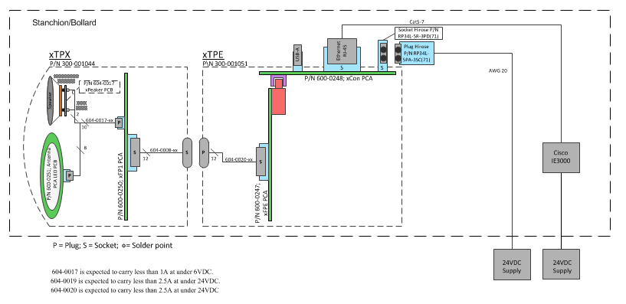

Figure 5.1: System Interconnect Diagram

# Communication System Diagrams

For more information about the communication system and how the xTP interacts with the xBRC, see the document 900-0103 Rev 1.0 xConnect System Support-xBRC.

# Subsystem Assembly Drawings

This section contains xTP assembly drawings and information about the xTP components.

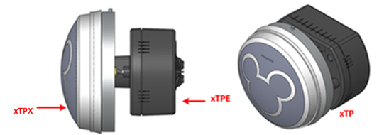

Figure 7.1: xTP Main Components

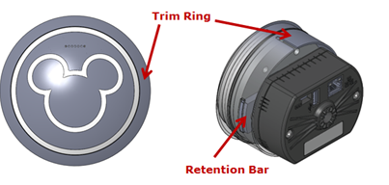

Figure 7.2 – Trim Ring and Retention Bar

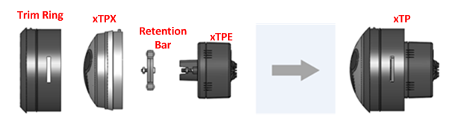

Figure 7.3 – xTP Assembly

# Component Data Sheet



Figure 8.1 – xTP Component

The following table provides the performance and other technical features of the xTP.

|  |  |
| --- | --- |
| **Component** | **Features** |
| Physical, xTP | * xTP Assembly PN: 300-001044 * Material, xTP: polycarbonate * Unit Weight, xTP: 314 grams (0.69 lbs.) |
| Environmental | * Operating Temperature: -10◦ C to 50◦ C * Operating Humidity: 90% condensing cycle * Environmental Sealing: IP56 |
| Electrical | * RFID: 13.56 MHz ISO-14443A band |
| Regulatory Compliance | * Handling: UL 1439 * Vision Safety: CIE/IEC 62471 * Safety: UL 60950-1 * EMC: FCC Part 15, Class K |

# Supply Chain Information

The table below shows the part numbers for the xTP and the xTPE. To order replacement components please call 206-381-0898 and tell them you are calling about replacement components for Disney.

|  |  |
| --- | --- |
| **Component** | **Features** |
| Physical, xTP | * xTP Assembly **PN**: **300-001044** * Material, xTP: PC * Unit Weight, xTP: 314 grams (0.69 lbs.) |

# Troubleshooting Guide

The following section is designed to help troubleshoot any potential problems with the xTP. This includes:

* The steps for removing and replacing the xTP.
* Steps required for xTP bring-up. Specifically, associating the xTP with the xBRC.
* Touch tests following replacement to ensure the xTP is functioning correctly.
* A list of potential problems and how to resolve or escalate each problem.

## Removing and replacing the xTP

The following section describes the process for removing and replacing the xTP. This includes step by step instructions for xTP removal and replacement. Note: This procedure is **not** used in the Park Entry DAP.

**xTP Swap Out Procedure:**

To remove the xTP:

1. Using a 3/16th Hex, turn the screw at the back of the stanchion counter clockwise.

|  |  |
| --- | --- |
| S:\projects\Disney\Scooter\Photos and Video\2012-08-21 FOS Swap Out Procedure\JPG\Thumbnails for Manual\xTP Stanchion-1\IMG_3776.jpg | S:\projects\Disney\Scooter\Photos and Video\2012-08-21 FOS Swap Out Procedure\JPG\Thumbnails for Manual\xTP Stanchion-1\IMG_3779.jpg |

Figure 10.1 – Turning the Hex Screw

1. Continue to turn the screw while gently pulling the xTP until it releases from the screw.

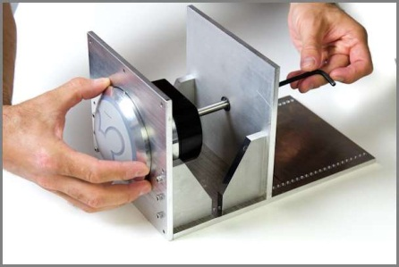

Figure 10.2 – Gently Pull the xTP from the Stanchion

1. Pull the xTP free of the stanchion taking care to not strain the Ethernet or power leads.

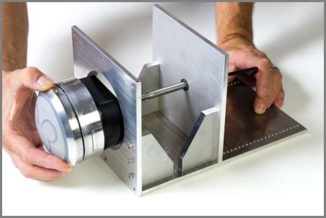

Figure 10.3 – Pulling the xTP Free

1. Unplug the Ethernet and power leads, leaving them hanging outside the stanchion opening, taking care not to let the leads fall back into the stanchion.

|  |  |
| --- | --- |
| S:\projects\Disney\Scooter\Photos and Video\2012-08-21 FOS Swap Out Procedure\JPG\Thumbnails for Manual\xTP Stanchion-1\IMG_3790-Edit.jpg | S:\projects\Disney\Scooter\Photos and Video\2012-08-21 FOS Swap Out Procedure\JPG\Thumbnails for Manual\xTP Stanchion-1\IMG_3795-Edit.jpg |

Figure 10.4 – Unplugging the Ethernet and Power Leads

To replace the xTP:

1. Ensure that the black O-ring is lubricated with Molykote 55 (provided by Engineering Services).

|  |  |
| --- | --- |
| S:\projects\Disney\Scooter\Photos and Video\2012-08-21 FOS Swap Out Procedure\JPG\Thumbnails for Manual\xTP Stanchion-1\IMG_3797.jpg |  |

Figure 10.5 – Lubricating the O-ring

1. Plug in the Ethernet and power leads into the ports at the back of the xTP.

|  |  |
| --- | --- |
| S:\projects\Disney\Scooter\Photos and Video\2012-08-21 FOS Swap Out Procedure\JPG\Thumbnails for Manual\xTP Stanchion-1\IMG_3804.jpg | S:\projects\Disney\Scooter\Photos and Video\2012-08-21 FOS Swap Out Procedure\JPG\Thumbnails for Manual\xTP Stanchion-1\IMG_3801.jpg |

Figure 10.6 – Plugging in the Ethernet and Power Leads

1. Wait for the Ethernet indicator lights to show connection and activity by blinking. Note that the blinking light should occur within a few seconds, but it may take up to two minutes.

|  |  |
| --- | --- |
| S:\projects\Disney\Scooter\Photos and Video\2012-08-21 FOS Swap Out Procedure\JPG\Thumbnails for Manual\xTP Stanchion-1\IMG_3807.jpg | S:\projects\Disney\Scooter\Photos and Video\2012-08-21 FOS Swap Out Procedure\JPG\Thumbnails for Manual\xTP Stanchion-1\IMG_3807-Edit.jpg |

Figure 10.7 – Ethernet Indicator Lights

1. Orient the xTP Trim Ring pin to the groove in the stanchion (12 o’clock).

|  |  |
| --- | --- |
| S:\projects\Disney\Scooter\Photos and Video\2012-08-21 FOS Swap Out Procedure\JPG\Thumbnails for Manual\xTP Stanchion-1\IMG_3809.jpg | S:\projects\Disney\Scooter\Photos and Video\2012-08-21 FOS Swap Out Procedure\JPG\Thumbnails for Manual\xTP Stanchion-1\IMG_3810.jpg |

Figure 10.8 – Orienting the Trim Ring

1. Push the xTP in until you meet resistance from the screw at the back of the stanchion.

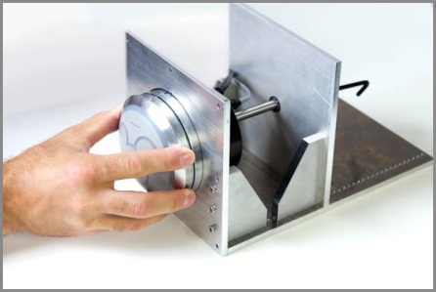

Figure 10.9 – Gently Push the xTP into the Stanchion

1. Turn the screw until the xTP is flush against the stanchion wall.

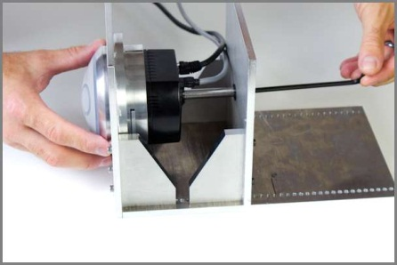

Figure 10.10 – xTP Flush Against Stanchion Wall

1. Continue to turn the screw until it feels snug.

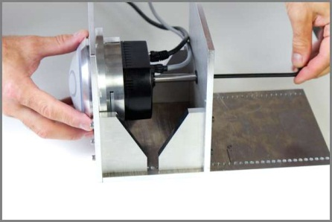

Figure 10.11 – Turning Screw Until it Feels Snug

1. The installation is complete.

## xTP Bring-up: xTP/xBRC Association

After the xTP has been swapped out and plugged in successfully, it starts sending HELLO messages to the xBRC. Once an xBRC hears the HELLO, it will mark that reader as an unassigned reader. There are multiple xBRCs deployed throughout Walt Disney World, but each attraction will have its own xBRC, simplifying the association process.

The following steps describe the process for associating the xTP with the xBRC:

1. The technician at attraction contacts the System Command Center and requests that a new or swapped out xTP be assigned to an xBRC.
2. The cast member at xBRC Management Console selects *Location Editor* from the xBRC **Home Page** <http://xBRC_IP:8090/UI>

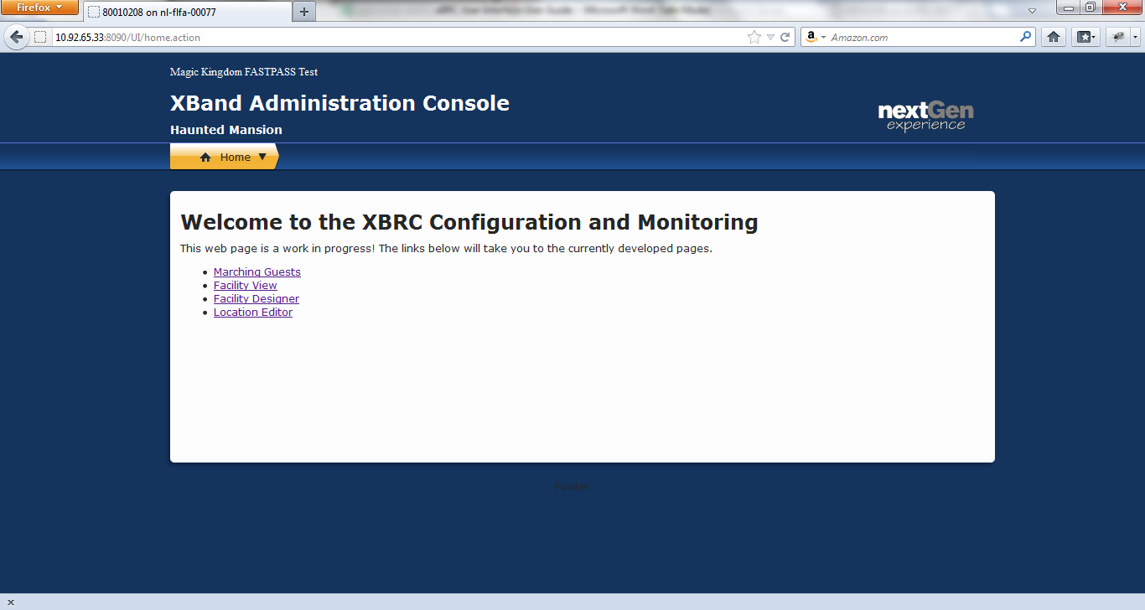

Figure 10.12 –xBRC Home Page

1. The cast member selects the Location from the menu on the right, clicks on the xTP (“Reader” as indicated on the screen) that’s being replaced, and then selects *Replace* from the drop down menu.

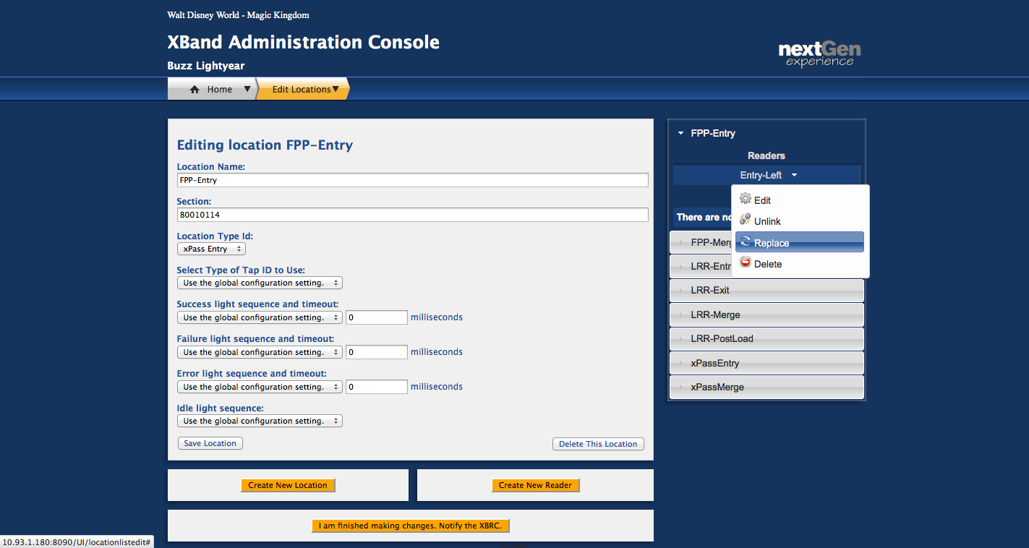

Figure 10.13 – Selecting Replace from Menu

1. Once the *Replace* link is clicked, this window will appear. Click on the unlinked (new) reader, which will appear as a MAC address.

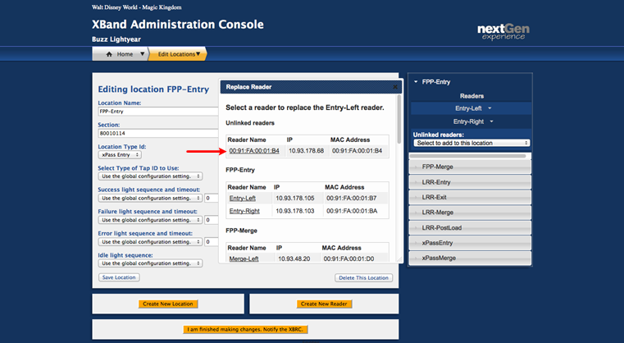

Figure 10.14 – Replace Reader

1. When the cast member clicks on the unlinked reader, this prompt will appear:

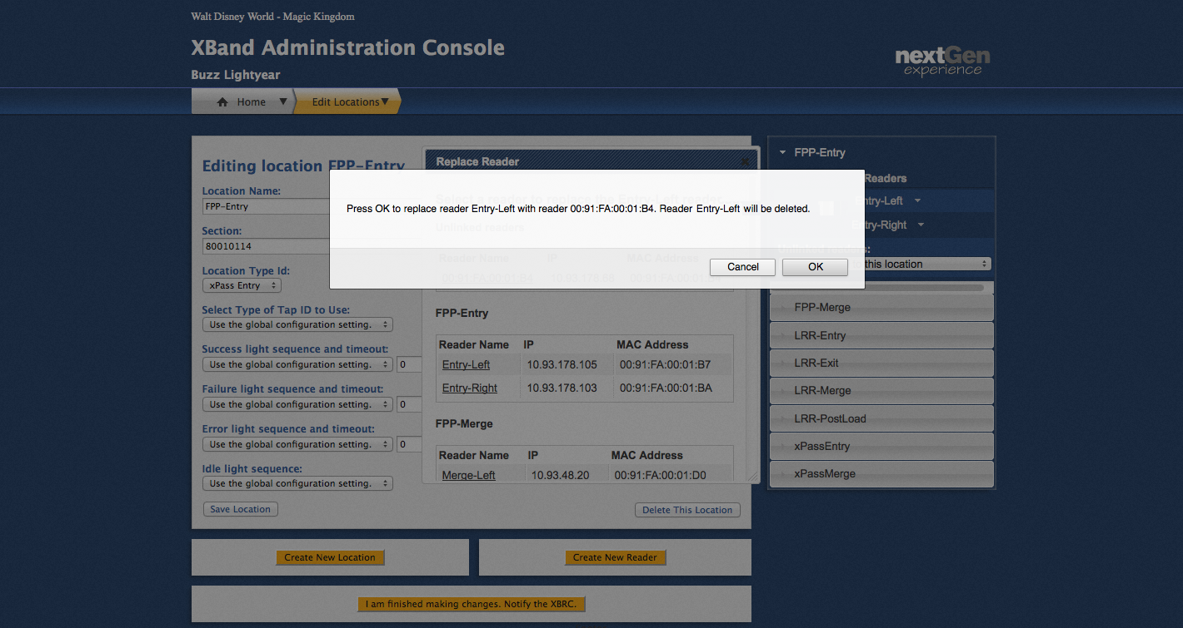

Figure 10.15 – Warning Notice

1. After selecting OK, the new reader has replaced the old reader in this location.
2. The technician at the attraction begins testing functionality with test card.

## Testing the xTP

The following table lists the tests to run after the replacement and the response that shows the xTP is functioning correctly.

|  |  |
| --- | --- |
| **Testing the xTP for main entry:** | **Expected Response:** |
| Tap with MagicBand that has an entry entitlement | The following sequences indicate a tap with a valid entry entitlement:  Park Entry (DAP) Process:   1. Service personnel tap the xTP. 2. “Tap” sound is played in sequence with light ring on the xTP flashing green. 3. Light flashes until system indicates the band or card belongs to a child or adult. 4. If Response comes back as adult.    1. Bio reader light flashes white 3 times in sequence with “bio scan prompt” sound.    2. Service personnel begins bio reader scan.    3. Upon completed scan, bio reader light goes through spinning animation while fingerprint is checked.    4. “Success” sound is played and all lights (Mickey, light ring, and bio ring) turn green for 1.5 seconds. 5. If Response comes back as child, “success” sound is played and Mickey light turns green for 1.5 seconds. |
| Tap with MagicBand that doesn’t have an entry entitlement | Service personnel tap xTP.  “Tap” sound is played and light ring on the xTP blinks green for short period.  “Exception” sound is played while light ring and bio ring flash blue. |
| **Testing the xTP for FastPass+:** | **Expected Response:** |
| Touch xTP with MagicBand (or card) that has a FastPass+ entitlement. | 1. Service personnel touch the xTP. 2. “Touch” sound is played in sequence with light ring on the xTP flashing green. 3. “Success” sound is played and all lights (Mickey and light ring,) turn green for about 1.5 seconds. |
| Touch xTP with MagicBand (or card) that doesn’t have FastPass+ entitlement. | Service personnel touch the xTP with MagicBand or card.  “Touch” sound is played and light ring on the xTP blinks green for a short period.  “Exception” sound is played while light ring flashes blue. |
|  | Test Complete |

## Troubleshooting problems with the xTP

The following table lists the problems that you might experience with the xTP and how you would resolve or escalate the problem.

|  |  |
| --- | --- |
| **Problem with the xTP** | **How to resolve or escalate this problem** |
| The LEDs in the xTP are not working | **How to identify**: When the xTP is tapped, the tap sound plays but the light ring on the xTP fails to flash green  **How to resolve**: Swap out the xTP following the instruction in section 10.1  **How to escalate**: N/A |
| The audio in the xTP is not working | **How to identify**: When the xTP is tapped, light ring flashes green but the tap sound fails to play  **How to resolve**: Swap out the xTP following the instruction in section 10.1  **How to escalate**: N/A |
| Both the LEDs and audio in the xTP are not working | **How to identify**: When the xTP is tapped, light ring on the xTP fails to flash green and the tap sound fails to play.  **How to resolve**: Check the power supplies and switch to ensure xTP has power and network connection. Troubleshoot as necessary. To swap out the xTP follow the instructions in Section 10.1.  **How to escalate**: N/A |
| The xTP is taking too long to read MagicBands | **How to identify**: It takes over 15 seconds for the xTP to respond to the tap.  **How to resolve**: N/A  **How to escalate**: This could have several causes (slow network and slow response from a software application being the most likely). Contact the control center for appropriate escalation. |
| The xTP loses power | **How to identify**: The xTP does not respond when tapped and fails to respond when power is applied  **How to resolve**: Check the power supplies and replace as necessary. Swap out the xTP following the instructions in Section 10.1.  **How to escalate**: N/A |

# Obsolete Equipment

The timeframe for the release of a new version of the xTP is TBD.